### 3D accelerometer experiment

An accelerometer is a device that measures [proper acceleration](https://en.wikipedia.org/wiki/Proper_acceleration).[[1]](https://en.wikipedia.org/wiki/Accelerometer#cite_note-Tinder-1) Proper acceleration, being the [acceleration](https://en.wikipedia.org/wiki/Acceleration) (or [rate of change](https://en.wikipedia.org/wiki/Rate_of_change) of [velocity](https://en.wikipedia.org/wiki/Velocity)) of a body in its own instantaneous [rest frame](https://en.wikipedia.org/wiki/Rest_frame),[[2]](https://en.wikipedia.org/wiki/Accelerometer#cite_note-Rindler-2) is not the same as coordinate acceleration, being the acceleration in a fixed [coordinate system](https://en.wikipedia.org/wiki/Coordinate_system). For example, an accelerometer at rest on the surface of the Earth will measure an [acceleration due to Earth's gravity](https://en.wikipedia.org/wiki/Gravitational_acceleration), straight upwards (by definition) of g ≈ 9.81 m/s2. By contrast, accelerometers in [free fall](https://en.wikipedia.org/wiki/Free_fall) (falling toward the center of the Earth at a rate of about 9.81 m/s2) will measure zero.

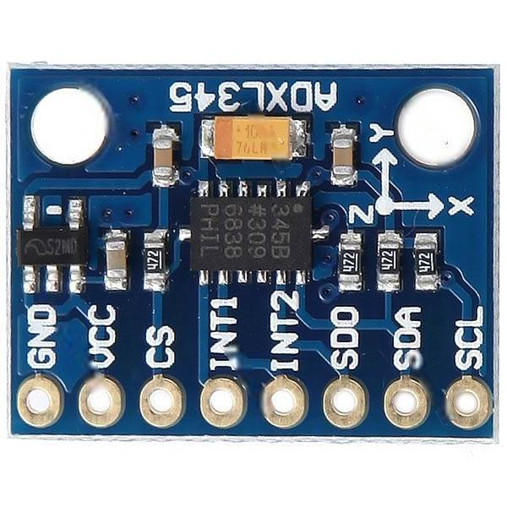

**Pin table to make connection**

|  |  |
| --- | --- |
| Module Connection | Pi Connection |
| VCC | 3v3 |
| Gnd | Gnd |
| SDA | SDA |
| SCL | SCL |

**Pin Diagram**

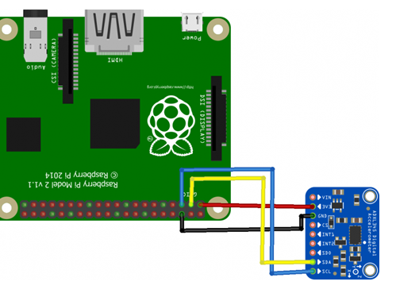

**Note:** Here if the Connection are loose or not properly connected than it will show error.

Sample Code to Display Input pressed in console: **triacc.py**

Code to send the input data through Socket: **triacc.py**

**Note:**

1. By default UDP Port is set to “5005” and IP to “10.10.1.20 “ to change the port number and IP address according to your receiver make changes in line 6 and 7
2. Regularly check the console for errors.